**INTEGRATOR USING IC - 741**

**OPERATIONAL AMPLIFIER**

**LAB # 09**



**Fall 2022**

**CSE-203L**

**Circuits & System-2 Lab**

Submitted by: **NAVEED AHMAD**

Registration No.: **22PWCSE2165**

Class Section: **B**

“On my Honor, as student of University of Engineering and Technology, I have neither given nor received unauthorized assistance on this academic work.”

Submitted to:

**Engr. Usman Malik**

09/12/2023

Department of Computer Systems Engineering

University of Engineering and Technology, Peshawar

**Integrator Using Ic-741**

**Operational Amplifier**

Objectives:

* Operation of the integrator using operational amplifier
* And trace of the output wave forms for the sine and square wave inputs

Equipment and Components:

* Oscilloscope
* AC Function Generator
* Digital Multi meter
* Resistors: 10kΩ, 22kΩ
* Capacitor 0.1µF
* Op-amp 741

Theory Overview:

A circuit in which the output voltage is the integration of the input voltage is called an integrator.

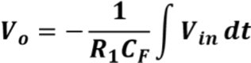

In the practical integrator shown in Figure 1, to reduce the error voltage at the output, a resistor RF is connected across the feedback capacitor CF. Thus, RF limits the low-frequency gain and hence minimizes the variations in the output voltage.

Integrator has wide applications in

* Analog computers used for solving differential equations in simulation arrangements.
* A/D Converters.
* Signal wave shaping.
* Function Generators.

Diagrams:

# 

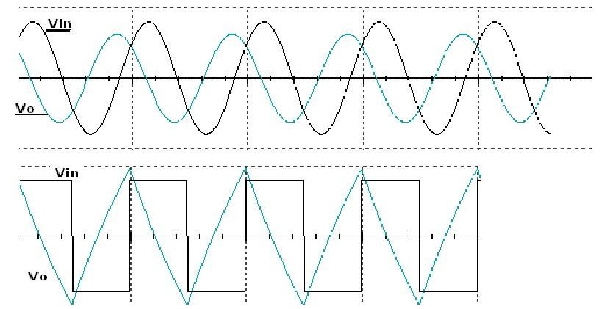

Procedure:

* Connect the components/equipment as shown in the circuit diagram Figure 2.
* Switch ON the power supply.
* Apply sine wave at the input terminals of the circuit using function Generator.
* Connect channel-1 of CRO at the input terminals and channel-2 at the output terminals.
* Observe the output of the circuit on the CRO which is a cosine wave (90o phase shifted from the sine wave input) and note down the position, the amplitude and the time period of Vin & Vo.
* Now apply the square wave as input signal.
* Observe the output of the circuit on the CRO which is a triangular wave and note down the position, the amplitude and the time period of Vin & Vo.
* Plot the output voltages corresponding to sine and square wave inputs as shown in the Figure 3 below.

**Circuit and Figures:**

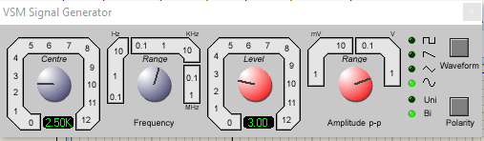

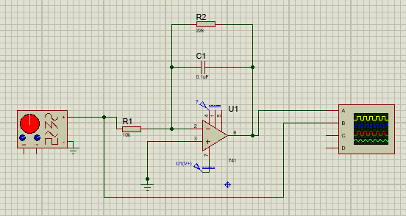 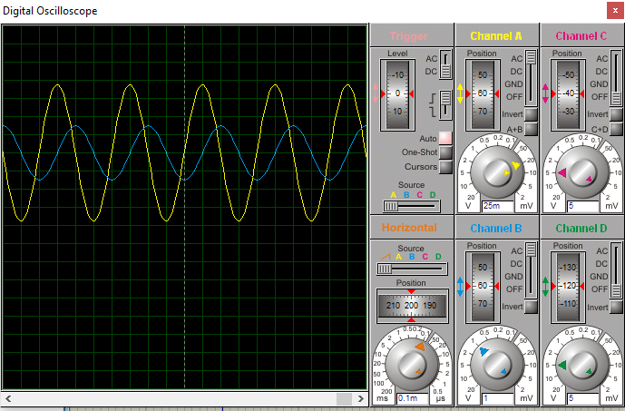

Calculations:

|  |  |  |  |  |
| --- | --- | --- | --- | --- |
| **Vin(p-p)** | **Frequency** | **Vo (Theoretical)** | **Vo (Experimental)** | **%Error** |
| 1 V | 1kHz | 0.159 V | 0.15 V | 0.6 % |
| 1 V | 2kHz | 0.0795 V | 0.07625 V | 4.2 % |
| 2 V | 1.5kHz | 0.2123 V | 0.205 V | 3.4 % |
| 2.5 V | 2.5kHz | 0.1592 V | 0.1575 V | 1.07 % |
| 3 V | 2.5kHz | 0. 191 V | 0.1875 V | 1.866 % |

Conclusion:

‘ The integrator circuit outputs the integral of the input signal over a frequency range based on the circuit time constant and the bandwidth of the amplifier. The input signal is applied to the inverting input so the output is inverted relative to the polarity of the input signal.

The integrator circuit is mostly used in analog computers, analog-to-digital converters and wave-shaping circuits. A common wave-shaping use is as a charge amplifier and they are usually constructed using an operational amplifier though they can use high gain discrete transistor configurations.